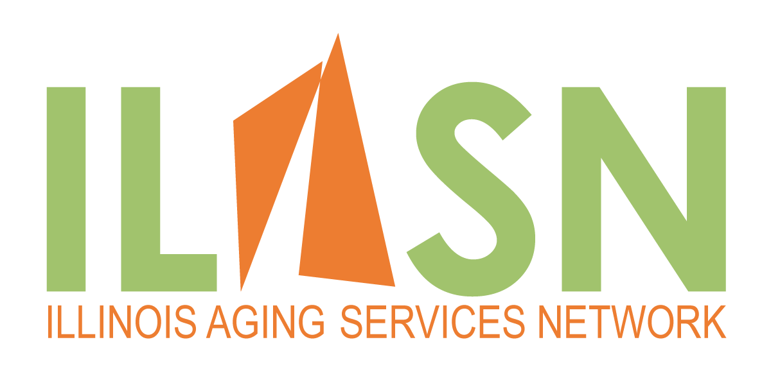
17 South High Street, Suite 1000
Columbus, Ohio 43215
614-228-9131
Application for Post-Acute Long-term Care Network Membership
Please complete and submit to Arlene Jaroscak at Arlene.Jaroscak@shcare.net.
Corporate Organization:
Corporate Address:

Tax ID Number:

NPI Number

Facility Names:

(Include SNF’s, AL’s, RCF’s, SLF’s, HHC, Hospice, etc.)

Corporate Contact Name:

Corporate Contact Email:

Corporate Contact Telephone Number:

CEO Name, Email, and Telephone Number:

Is the organization a member in good standing with LeadingAge Illinois? |  |  | Yes or No
Is the organization a not-for-profit? |  |  | Yes or No
Please list all services, including SNF’s, Assisted Living, Residential Care, SLF’s, Home Health Care, Hospice, etc., and (certified beds/capacity for each) provided by your organization:
Please list the geographic areas your organization and facilities cover (counties and part of counties), with names and addresses:
Please Indicate your overall current Star Rating and Today’s Date for each facility:
Mandatory Participation Criteria: Please indicate your ability to participate in network contracting and quality requirements:  - Organization will participate in at least 80% of negotiated contracts.  - Organization will comply with all ILASN quality program requirements. |  | (circle)  Yes or No  Yes or No

Thank you for your application. The ILASN Board will consider your application. Completing of the application is not a guarantee of acceptance. If accepted, we will contact you ASAP with the appropriate corporate documents for completion.

Please contact Arlene Jaroscak with any questions at Arlene.Jaroscak@shcare.net.

